**CS302: Modeling and Simulation**

**Lab-3 Report**

**201501459: Luv Patel**

**201501461: Harshal Khodifad**

**Q1. (Modeling Inuenza) Implement the SIR model of Inuenza.**

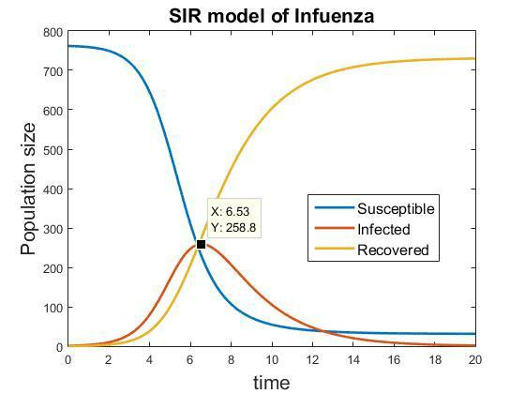

***PROBLEM AND ASSUMPTIONS:***

* In this assignment, we have been asked to study the effect of vaccination when introduced over a standard SIR model of Influenza.
* The initializations throughout the analysis are as follows:

So = 762 (Initial Susceptible Population)

Io = 1 (Initial Infected Population), Ro = 0 (Initial Recovered Population)

* β = 0.00218 (the constant representing δ***c***/***N*** where δ = mean number of susceptibles

that an infected meets and c = probability that an interaction between a susceptible and infected leads to a transmission.

* Recovery Rate : 0.5
* Vaccination rate ⇒ Varies, in order to compare between all the three sub-problems and identify, when is it fruitful to start vaccination.

Assumption: Once a person is vaccinated, he is never susceptible.

1. **Adjust the SIR model to allow for vaccination of susceptible boys. Assume that 15% are vaccinated each day, and make a simplifying assumption that immunization begins immediately. Discuss the effect on the duration and intensity of the epidemic. Consider the impact of other vaccination rates.**

**Ans.** Assumption:

* + The immunization due to vaccination begins as soon as the vaccine is consumed.
  + The vaccination happens only at the start of the day

Depending upon the vaccination rates, the peak for the number of infecteds will vary and so will the duration of the epidemic.

For higher vaccination rates, the decrease in susceptibles would lead to less increase in infecteds and hence the duration of the epidemic would be lesser.

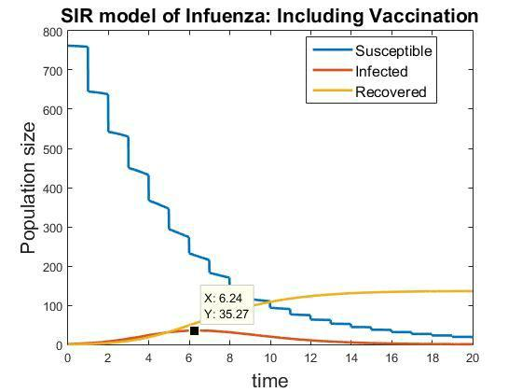

**Observations(compared to vaccination rate = 0 , see Fig. 1) :**

* **Steps in the Susceptibles curve : ​**The steps in the susceptibles’ curve is because ofthe assumption that the vaccination happens only at the start of the day. Which implies the decrease would happen over a single moment everyday.
* **Decreased peak of the Infecteds curve : ​**As we are vaccinating the susceptibles at thestart of the each day, we are essentially decreasing the input for the infecteds.
* **Decreased saturation value of the Recoveries : ​**As a result of decreased susceptiblesdue to vaccination, infecteds decrease which are the input for the recoveries.
* **Decreased epidemic duration : ​**The epidemic continues till we have an infected in thepopulation. So, one can easily observe the time when the number of infecteds go down to zero.

Here, the vaccination rate is kept to 15%, i.e. 15% of the susceptibles are vaccinated on a daily basis. Obviously, having any rate > 0 for vaccination would result in smaller peak for number of infecteds because of decreased number of susceptibles. Also the decreased number of infecteds would lead to decreased duration of the epidemic.

And since the number of Infecteds is proportional to the increase in the number of Recoveries, the peak for recoveries also decrease.

**Intuitive Explanation :**

Essentially by including vaccination, we have changed the compartment model and intuitively introduced a new compartment of “Vaccinated”.

Following is the compartment model for it :

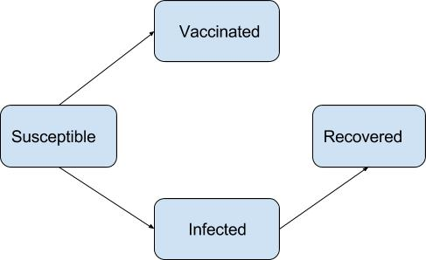

**For other value of vaccination rate :**

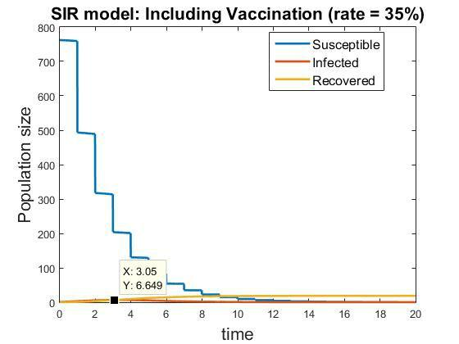

**Observations(as compared to 15% vaccination rate):**

* **Steps’ height increase : ​**As the vaccination rates increase, the instantaneouschange(decrease) in the susceptible population increase. As now the percentage of susceptibles remaining after each vaccination would be lesser.
* **Infecteds are extremely low, so are the recoveries :​**Since the vaccination rate isextremely high, the susceptibles decrease by a large amount for the initial periods and thus the number of possible meetings between an infected and a
* **The duration of epidemic is extremely small : ​**Since the infecteds never increase to asignificant value, the duration of the infection is less too.

So, as we increased the vaccination rate, one can visualise as explained the decreased number of infecteds, hence decreased number of recoveries and also the decreased epidemic time, vis-a-vis original SIR problem. The epidemic time can be noted when the susceptibles go down to 0.

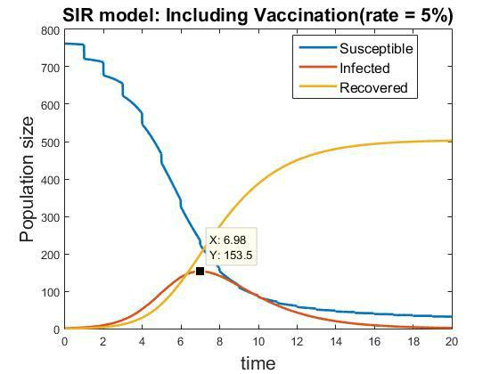

**Observations (as compared to 15% vaccination rate, only exceptional observations):**

* + **The curve tends to the original SIR model for later times : ​**Since the rate ofvaccination is extremely small, for lower values of susceptible the decrease is negligible. And hence the curve tends to the original model at the end of the epidemic.
  + **The Epidemic period is almost same : ​**As explained, as time increases, the curvetends to that of the original SIR model. Hence, the decrease in susceptible population due to vaccination is negligible for later period, which is the reason why the time duration of epidemic is almost same as the original model.

1. **Adjust the SIR model to allow for vaccination of susceptible boys. Assume that 15% are vaccinated each day and that immunization begins after three days. Discuss the effect on the duration and intensity of the epidemic. Consider the impact of other vaccination rates.**

**Ans.**

This question asks to analyse the effect of delay in vaccination. Essentially we need to analyse that by when shall we start the vaccination, i.e. if we start the vaccination after the peak for Infecteds has been achieved then it is not effective.

Hence, to reduce the effect of epidemic or to decrease the number of people getting infected by the disease, we need to apply vaccination before the peak is reached

**Assumptions :**

* The question states that vaccination happens after a delay.
* The immunization begins as soon as the vaccination is applied.

We know that for the original model, the infected is at its peak at 6.5 days. Hence, for the vaccination to be beneficial, we have to begin vaccination before 6th day.

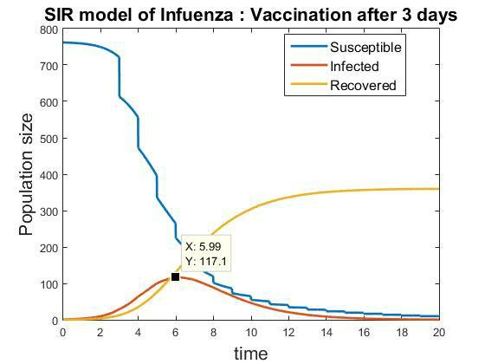

**Observations(as compared to original SIR model):**

* **Decreased peak value for the Infecteds and Recoveries: ​**As we are vaccinating thesusceptibles at the start of the each day, we are essentially decreasing the input for the infecteds. And hence, decreasing the input for Recoveries.
* **Decreased epidemic duration: ​**Since the vaccination application is before the peak, itis successful and hence reduces the infecteds resulting in decreased time of the epidemic.

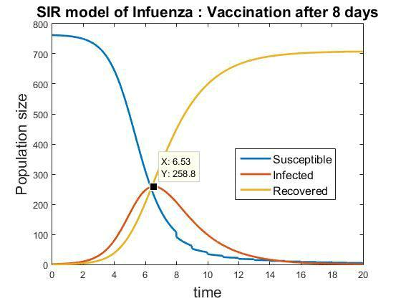

**Observations(compared with the original SIR) :**

* **Same peak as the original SIR for Infected : ​**Until and unless vaccination is introduced,the graph follows the original SIR curve. Hence if we introduce the vaccination after the peak of infected, it won’t effect the maximum value of infected, and is of no use. As when vaccination happens, the infecteds are already on decline.

**Q2. (Modeling SARS) Read the SARS model and using Fig. 6.2.4 obtain the set of diﬀerential equations.**

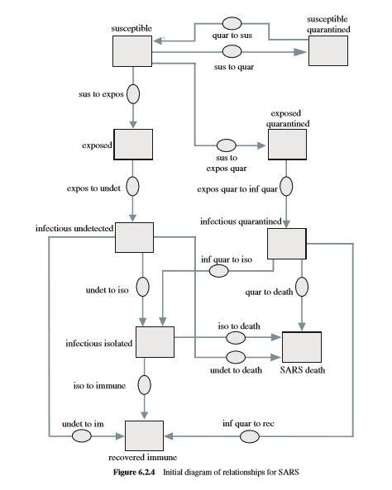

**The set of differential equations are:**

|  |  |  |  |  |  |  |  |  |  |  |  |  |  |  |  |  |  |  |  |  |  |  |  |  |  |  |  |
| --- | --- | --- | --- | --- | --- | --- | --- | --- | --- | --- | --- | --- | --- | --- | --- | --- | --- | --- | --- | --- | --- | --- | --- | --- | --- | --- | --- |
| ***dS*** | | | | | | = | −***k***·***b***·***Iu***·***S*** | | | | | |  |  | − ***q***(1−***b***)·***k***·***Iu***·***S*** | | | | | | | | | | + ***u*** · ***S*** | ***Q*** |  |
| ***dt*** |  |  |  |  |  |  |  |  | ***N*** | 0 | |  |  |  |  |  |  |  |  | ***N*** | 0 |  |  |  |  |  |
|  |  |  |  |  |  |  |  |  |  |  |  |  |  |  |  |  |  |  |  |  |  |  |  |  |
| ***dSQ*** | | | | | | = |  |  | ***q***(1−***b***)·***k***·***Iu***·***S*** | | | | | | | | | |  | − ***u*** · ***S*** | | | ***Q*** | |  |  |  |
| ***dt*** | | | | |  |  |  |  |  |  | ***N*** | | 0 | | |  |  |  |  |  |  |  |  |  |  |
|  |  |  |  |  |  |  |  |  |  |  |  |  |  |  |  |  |  |  |  |  |  |  |  |  |
| ***dE*** | |  |  |  | | = (1 − ***q***) | | | | | | | | ***k***·***b***·***Iu***·***S*** | | | | | | − ***p*** · ***E*** | | | | |  |  |  |
| ***dt*** | | | | | |  | |  | | | |  |  |  |
|  |  |  |  |  |  |  |  |  | ***N*** | | 0 | |  |  |  |  |  |  |  |  |  |
|  |  |  |  |  |  |  |  |  |  |  |  |  |  |  |  |  |  |  |  |  |  |  |  |  |  |
| ***dEQ*** | | | | | | = (***q***) | | | | | ***k***·***b***·***Iu***·***S*** | | | | |  |  |  | − ***p*** · ***E*** | | | ***Q*** | | |  |  |  |
| ***dt*** | | | | | |  | | | | |  |  |  |  |  |
|  |  |  |  |  | ***N*** | | | | 0 |  |  |  |  |  |  |  |  |  |
|  |  |  |  |  |  |  |  |  |  |  |  |  |  |  |  |  |  |  |  |  |  |  |  |  |  |  |
| ***dIu*** | | |  | = ***p*** · ***E*** − (***m*** + ***w*** + ***v***) · ***Iu*** | | | | | | | | | | | | | | | | | | | | | |  |  |
| ***dt*** | | |  |  |
| ***dI*** | | | | | |  |  |  |  |  |  |  |  |  |  |  |  |  |  |  |  |  |  |  |  |  |  |
| ***Q*** | | | | = ***p*** · ***EQ*** − (***m*** + ***w*** + ***v***) · ***IQ*** | | | | | | | | | | | | | | | | | | | | | |  |  |
| ***dt*** | | | |  |  |
| ***dI*** | | | | | | = ***w***(***Iu*** + ***IQ***) − (***m*** + ***v***)***ID*** | | | | | | | | | | | | | | | | | | | |  |  |
| ***D*** | | | |  | |  |  |
| ***dt*** | | | |  |  |

***dDdt*** = ***m***(***Iu*** + ***ID*** + ***IQ*** )

***dRdt*** = ***v***(***Iu*** + ***ID*** + ***IQ*** )

1. **Complete the Lipsitch SARS model introduced in the text. Have the model evaluate R. Produce graphs and a table of appropriate populations, including susceptible, recovered_immune, SARS_death, and the total of the ve categories of infecteds. Employ the following parameters: k = 10/day; b = 0.06; 1/p = 5 days; v = 0.04, m = 0.0975, and w = 0.0625, so that v + m + w = 0.2/day and 1/(v + m + w) = 5 days; 1/u = 10 days; N0 = 10,000,000 people. Vary q from 0 upward. Discuss the results.**

**Ans.**

* + By using the above mentioned differential equations, we get the following graph for the susceptibles, recovered_immune, SARS_death, and the total of the ve categories of infecteds:

(The parameter values used are as mentioned in the question. q is taken 0.05)

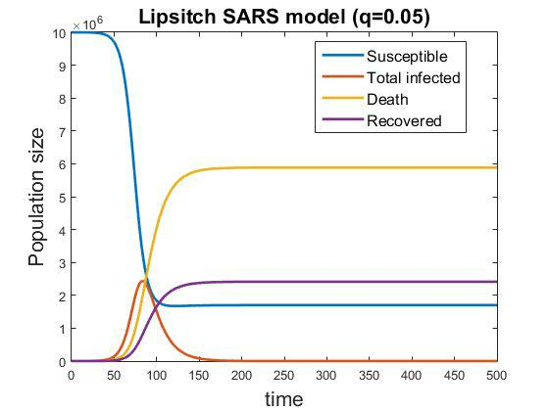

**Observations**

* **Susceptible decrease with time:**
  + It is assumed that the entire population is susceptible to the disease.
  + As the susceptibles interact with the infected population, they become infected, and the natural birth has not been considered here.
  + So, the number of susceptibles keep on decreasing based on the number of infected present at that time.
* **Infected increase to a peak, then decrease to zero:**
  + When the infected come in contact with the susceptibles, the susceptibles become infected and hence, the infected population increases.
  + The infected population keeps on increasing, till a peak value then decreases.
  + The reason for the decrease is that a certain proportion of population is getting recovered, as well as dies.
  + And, as the entire infected population eventually is dead or recovered, it goes to zero.
* **The recovered_immune and death population increases:**
  + With time, the infected population is either dead or gets recovered.
  + So, both the population increase with time.
  + Their population starts increasing only after there is an infected population, and they are zero initially.
* **The population values saturate to a certain value:**
  + As explained above, the infected population eventually goes to zero.
  + Once there is no infected person, susceptibles cannot get in contact with anyone and become infected, and so they don’t decrease anymore and become constant.
  + Similarly, when the infected population becomes zero, there is no input to the recovered or dead population, and they don’t change.

**Q. Vary q from 0 upward. Discuss the results.**

**Ans.**

* + We have to vary the value of q: the part of susceptibles moving to quarantined state.
  + We increase the value of q starting from 0, and analyze its effect on each type of population separately.

1. **Effect on susceptibles:**

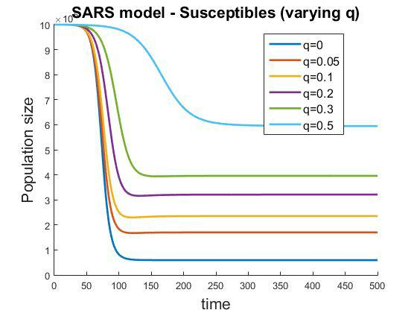

**Observations**

* **As the value of q is increasing, the number of susceptibles are decreasing at a lower rate.**
  + The reason is that as more people are moved to quarantined state, there are less contacts with the infected persons.
  + So, it leads to lesser infections.
  + So, the rate of outflow from the susceptibles is lower for higher values of q.
* **As the value of q is increasing, the number of susceptibles saturate at a higher value.**
  + The decrease in the number of susceptibles depends on the interaction with the infected population.
  + For higher values of q, more susceptibles are moved to quarantined state.
  + Lesser interaction with infected people leads to lesser infection.
  + So, as there is less transmission of infection, and so less susceptibles become infected.

**(2) Effect on total infected:**

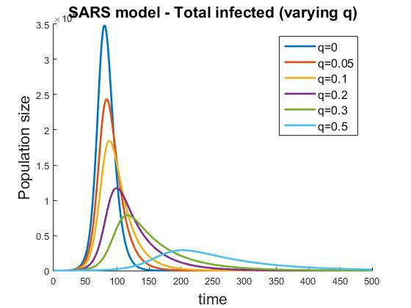

**Observations**

* **As the value of q is increasing, the maximum value of total number of infected is decreasing:**
  + The reason is that as q increases, more number of people are moved to quarantined state.
  + These people are not susceptible to the disease and hence less number are infected.
* **The rate of increase is slower for higher q:**
  + There are less number of people susceptible to the disease if more number is moved to the quarantined state.
  + So, there are lesser contacts that result in infection, that is, less transmission.
  + As q increases, the rate of getting infected decreases due to less available susceptible population.

**(3) Effect on death:**

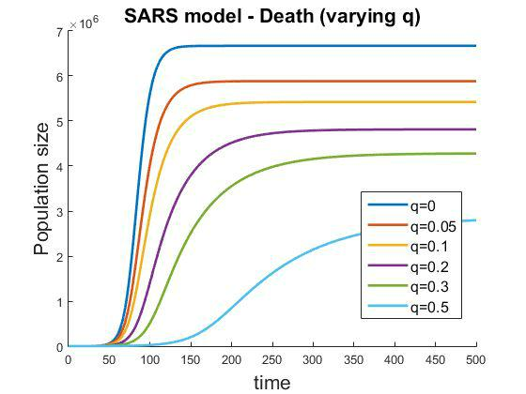

**Observations**

* **As q increases, number of deaths decrease.**
  + This is expected because the death considered here is only from the infected population.
  + And, with increase in q, the infected population is decreasing, and as a result less people are becoming dead.
* **As q increases, rate of increase of death decreases.**
  + This happens because the rate of increase of infected decreases with increase in the value of q.

**(4) Effect on recovered:**

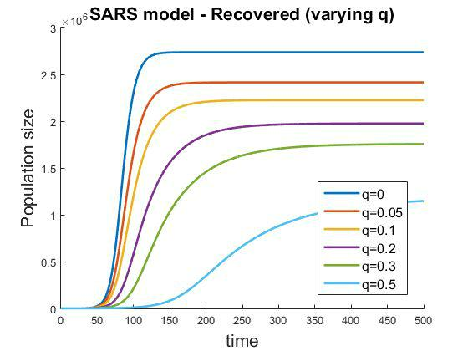

**Observations**

* **As q increases, number of recovered decrease.**
  + This is expected because the recovery is only from the infected population.
  + And, with increase in q, the infected population is decreasing, and as a result less people are getting recovered.

.

* **As q increases, rate of increase of recovered decreases.**
  + This happens because the rate of increase of infected decreases with increase in the value of q.

1. **After developing the model of part (a), with a xed value of q, test other ranges of k from 5 to 20 per day. Discuss the results.**

**Ans.**

* + Fixed value of q used: 0.05
  + We have to vary the value of k: the mean number of contacts of an infectious person with a susceptible person.
  + We increase the value of k from 5 to 20, and analyze its effect on each type of population separately.

**(1) Effect on susceptibles:**

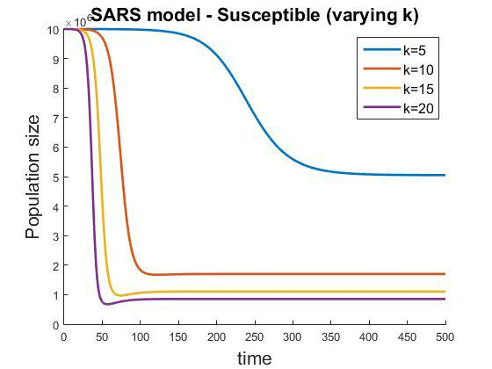

**Observations**

* **As k increases, number of susceptibles are decreasing at a higher rate.**
  + k increases means that the contacts between a susceptible and an infected person increase.
  + So, the number of susceptibles getting infected increases more for higher values of k.
  + As a result, the rate of decrease is higher.
* **As k increases, the number of susceptibles saturate at a lower value.**
  + With increase in the value of k, more susceptibles are getting infected due to increase in interaction.
  + This leads to higher decrease in the number of susceptibles for higher values of k.

**(2) Effect on total infected:**

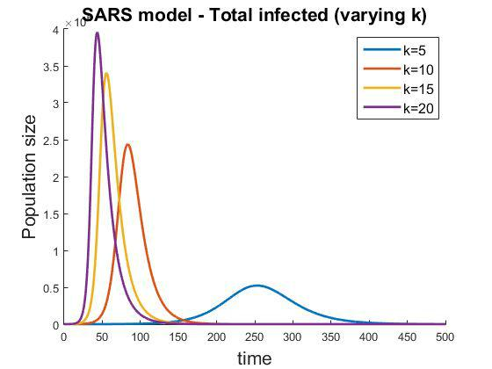

**Observations**

* **As k increases, the maximum value of total number of infected is increases:**
  + k increases means that the contacts between a susceptible and an infected person increase.
  + The number of susceptibles getting infected increases more for higher values of k.
  + Hence, there is an increase in the infected population.
* **The rate of increase is slower for lower k:**
  + There are less number contacts for lower k.
  + So, the interactions are lesser, which implies transmission of infection is lesser.
  + So, the rate of increase of infected population is lesser.

**(3) Effect on recovered:**

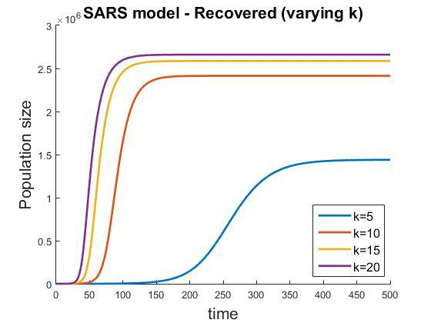

**Observations**

* **As k increases, number of recovered increases.**
  + This is expected because the recovery is only from the infected population.
  + And, with increase in k, the infected population is increasing, and as a result more people are getting recovered.

.

* **As k increases, rate of increase of recovered increases.**
  + This happens because the rate of increase of infected increases with increase in the value of k.

**(4) Effect on death:**

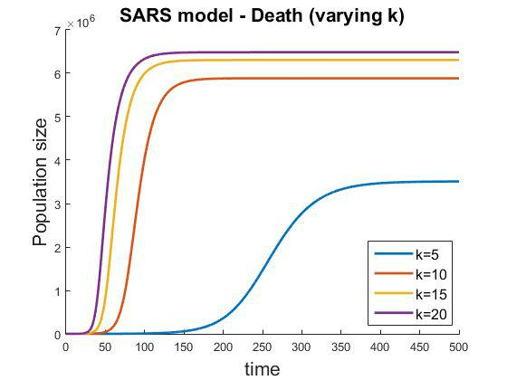

**Observations**

* **As k increases, number of deaths increase.**
  + This is expected because the death is only of the infected population.
  + Here, natural deaths are not considered.
  + And, with increase in k, the infected population is increasing, and as a result more people are becoming dead.

.

* **As k increases, rate of increase of deaths increases.**
  + This happens because the rate of increase of infected population increases with increase in the value of k.

1. **After developing the model of part (a), with a xed value of q, test other ranges of 1/(v + m + w) from 1 to 5 days.**

**Ans.**

* + Fixed value of q used: 0.05
  + We have to vary the value of ​**1/(v + m + w)​**:​**​**the average ​**duration** **​**of infectiousness.
  + We increase the value of 1/(v + m + w) from 1 to 5 days, and analyze its effect on each type of population separately.

**(1) Effect on susceptibles:**

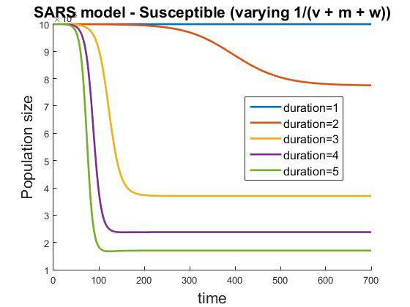

**Observations**

* **As the duration of infectiousness increases, number of susceptibles are decreasing at a higher rate.**
  + ‘duration’ increases means that the infected person remains infected for a higher duration.
  + So, the infected person can come in contact with more susceptibles in the period of infection.
  + So, the number of susceptibles getting infected increases more for higher values of the duration of infection.
  + As a result, the rate of decrease is higher.
* **As ‘duration’ increases, the number of susceptibles saturate at a lower value.**
  + With increase in the value of ‘duration’, more susceptibles are getting infected due to increase in interaction.
    - This leads to higher decrease in the number of susceptibles for higher values of k.
  + **The susceptible population does not decrease much for duration=1.**
    - This value of duration is too less for the susceptible population to get in contact with the infected population and get infected.
    - So, very few people are getting infected and the susceptible population decreases very less.

1. **Effect on total infected:**

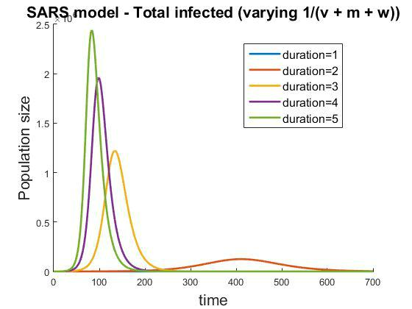

**Observations**

* **As ‘duration’ increases, the maximum value of total number of infected is increases:**
  + ‘duration’ increases means that the infected person remains infected for a higher duration.
  + So, the infected person can come in contact with more susceptibles in the period of infection.
  + So, the number of susceptibles getting infected increases more for higher values of the duration of infection.
  + Hence, there is an increase in the infected population.
* **The rate of increase is slower for lower ‘duration’:**
  + The person remains infected for a lesser duration of time.
  + So, the interactions are lesser, which implies transmission of infection is lesser.
  + So, the rate of increase of infected population is lesser.

* + **The infected population does not increase much for duration=1.**
    - This value of duration is too less for the susceptible population to get in contact with the infected population and get infected.
    - So, very few people are getting infected.
    - Hence, there is not much change in the number of infected population.

1. **Effect on recovered:**

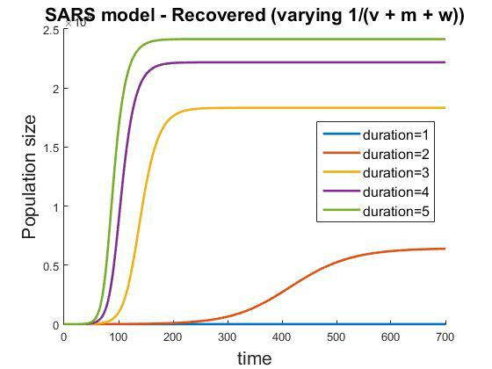

**Observations**

* **As ‘duration’ increases, number of recovered increases.**
  + This is expected because the recovery is only from the infected population.
  + And, with increase in ‘duration’, the infected population is increasing, and as a result more people are getting recovered.

.

* **As ‘duration’ increases, rate of increase of recovered increases.**
  + This happens because the rate of increase of infected increases with increase in the value of ‘duration’.

**(4) Effect on death:**

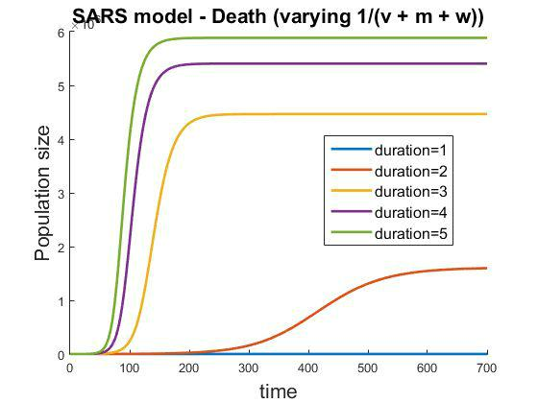

**Observations**

* **As ‘duration’ increases, number of deaths increase.**
  + This is expected because the death is only of the infected population.
  + Here, natural deaths are not considered.
  + And, with increase in ‘duration’, the infected population is increasing, and as a result more people are becoming dead.

.

* **As ‘duration’ increases, rate of increase of deaths increases.**
  + This happens because the rate of increase of infected population increases with increase in the value of ‘duration’.

1. **Adjust the model of part (a) so that the simulation is allowed to run for a while before quarantine and isolation measures that reduce R to below 1 are instituted. Discuss the implications on the number of people quarantined and on the health care system of not taking aggressive measures initially.**

**Ans.**

* + We have to keep the parameter values such that the value of R is below 1.
  + An undetected infectious person has k contacts per day with a susceptible person.
  + Of these, with a probability b of transmission, kb new cases of SARS result each day.
  + Because the average duration of infectiousness is 1/(v + m + w) days, without quarantine being a factor, one infectious person eventually gives rise to R = kb/ (v + m + w) secondary infectious cases of SARS.
  + However, when a fraction, q, go into quarantine so that a fraction (1 − q) do not, the reproductive number is:

|  |  |  |  |
| --- | --- | --- | --- |
| R = | ***kb*** | (1 − ***q***) |  |
| ***v***+***m***+***w*** |  |



* The larger q is, the smaller R is, and the less severe the impact v+m+w of the disease is.

Given, k=10, b=0.06, v=0.04, m=0.0975, w=0.0625.

For R<1:

|  |  |  |  |
| --- | --- | --- | --- |
| ***kb*** | (1 − ***q***) | < 1 |  |
| ***v***+***m***+***w*** |  |



* 0.6*5*(1-q) < 1
* (1 − ***q***) < 13
* ***q*** >23

So, we choose the value of ​**q = 0.7​**that keep the quarantine measures that reduce R to below 1.

* The plot for the infected - undetected when the above parameters are taken is as shown:

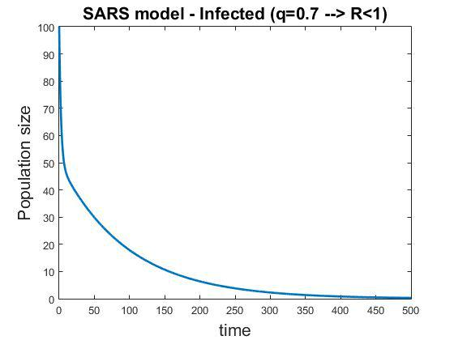

**Observations**

* **No increase:​**The number of infected keep on decreasing from the initial value.
* **No ‘epidemic spread’: ​**As the quarantine measures are taken immediately so as toreduce the reproduction number R below 1, the number of infected do not increase, and so there is no spread of the epidemic.

Now, we have to consider the case when the simulation is allowed to run for a while before quarantine and isolation measures that reduce R to below 1 are instituted.

We introduce a new term:

**delay​**:​number of days after which the quarantine and isolation measures are instituted​.

Depending on delay, the number of infected increase to a certain value, and so the epidemic is spread in different proportions.

If no quarantine measures are adopted, i.e. a simple SIR model, then the number of infected are as shown:

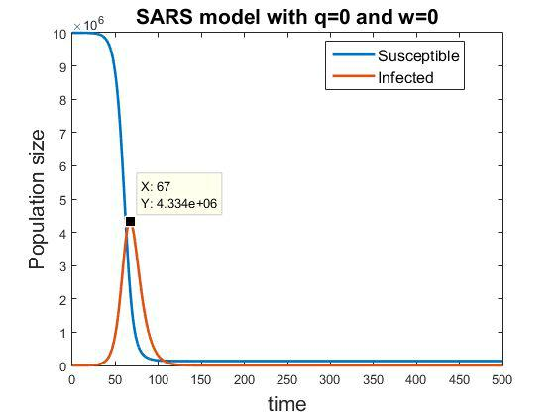

**Observations**

* **Peak value: ​**The peak value of the number of infected is reached after 67 days after thedisease is introduced.
* **All are infected:​**Almost everyone has the disease till 100 days, and we can say that theepidemic has spread as it has affected almost the entire population.
* **We can infer that if no quarantine measures are taken before 67 days, i.e. before the peak of number of infected is reached, there is no use of it as the epidemic would have spread.**
* **If the quarantine measures are taken before the number of infected start increasing, or before they reach the maximum value, we can control the number of infected, and the disease will spread to lesser portion of population.**

We will observe the number of infected for different values of ‘delay’.

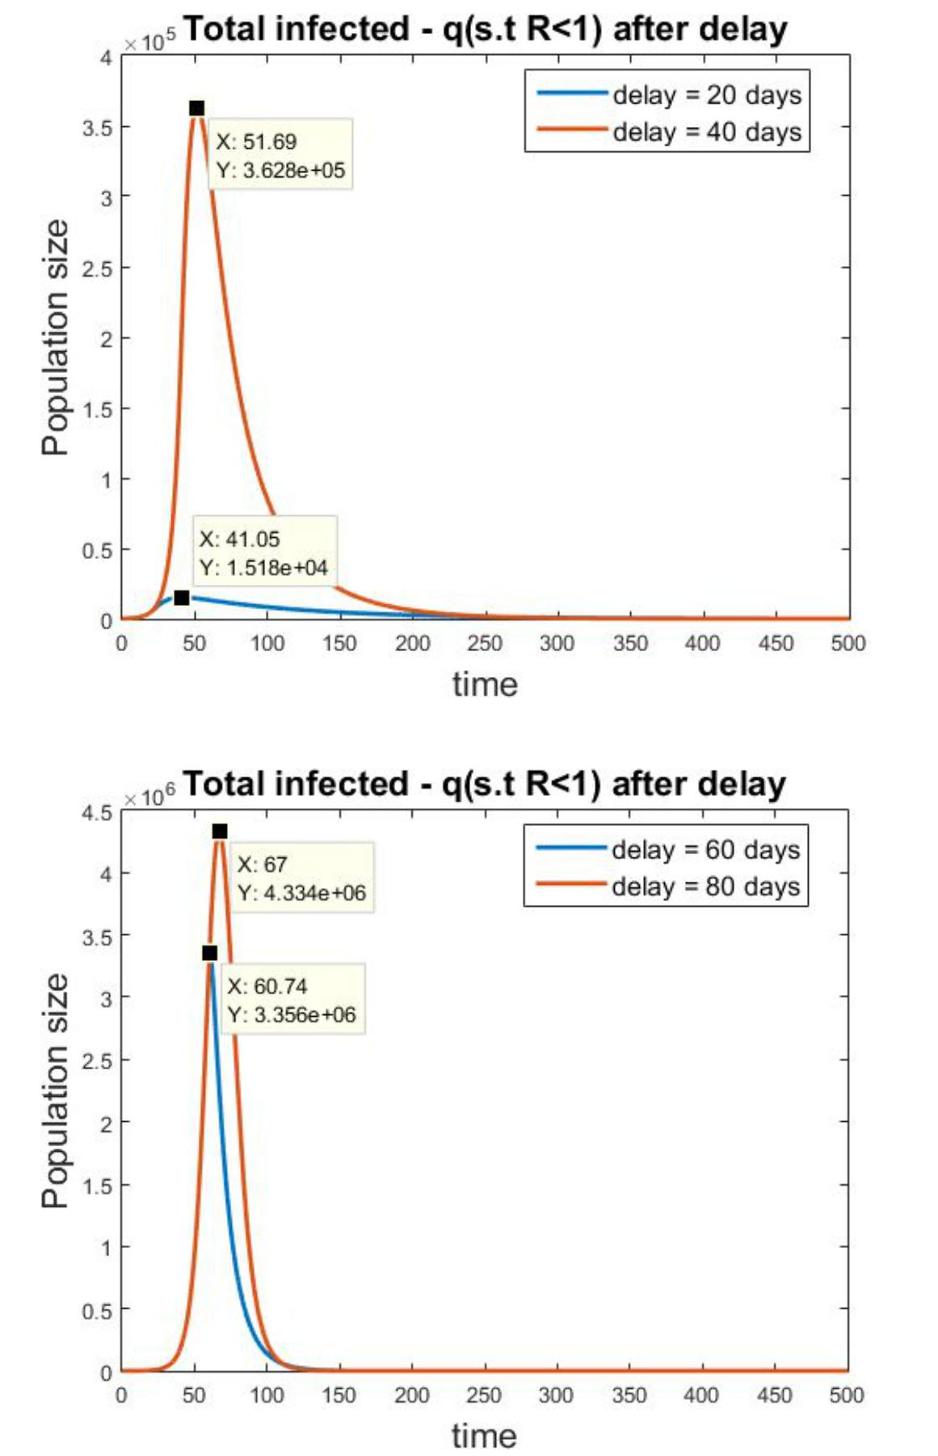

**Observations**

* **Peak values:**
  + The peak values for the number of infected are different for different values of delay.
  + For small values of delay, the number of infected do not rise to a large number, as the quarantine measures that reduce the R to less than 1 are instituted, and so the rate of change of the infected undetected is negative after that time.
  + For large values, the peak value is higher because the quarantine measures are instituted very late. Till then, the number of infected have already increased to a large number, so introduction of quarantine measures will not affect it significantly.
* **Effect of delay in quarantine measures:**
  + We had observed above that the number of infected reach its peak value in 67 days if no quarantine measures are instituted.
  + **So, the quarantine measures are useful to stop the spread of epidemic only if they are adopted quickly.**
  + **For delay=80 days, peak same as that when no quarantine measures adopted.**
  + Here, the majority of population has been affected by the time quarantine measures are adopted.
  + **For delay=20 days, peak value in order of** 103 **, compared to that when no quarantine measures are taken, which is order of** 106 **.**
  + So, if the measures are adopted initially, in 20 days, the number does not rise very much, and remains in control.

**Hence..**

* It can be said that as the number of people quarantined increase, the spread of epidemic can be controlled, and lesser number of people get infected.
* But, these measures have to be taken initially, otherwise the number of infected rise to a great extent even if the measures are instituted.